WireMock with Prometheus Metrics Extension — Detailed Explanation

1. WireMock
What it is:
WireMock is a tool for mocking HTTP services — it lets you simulate HTTP APIs, useful for testing and development without relying on real backend services.
Key functions:
- Runs an HTTP server on a port (default 8080)
- Accepts requests and matches them against “stub mappings”
- Returns predefined responses based on those mappings
- Logs requests and responses for later inspection (optional)
- Can be extended with plugins/extensions
How it runs:
- Usually run as a standalone Java app or inside Docker container
- Listens for incoming HTTP requests on a specified port
- Serves stubbed responses defined by JSON files (called mappings) or via API calls

2. Stub Mappings
What they are:
Stub mappings are JSON files or API-defined rules that tell WireMock how to respond to specific HTTP requests. For example, “when a GET request to /api/user/1 comes in, respond with JSON { "id": 1, "name": "Alice" }.”
How they work:
- Stored on disk (default mappings/ folder) or loaded dynamically
- WireMock uses these mappings to match incoming HTTP requests
- If no stub matches, WireMock responds with “No response could be served…” message

3. Extensions
WireMock can be extended via Java plugins (extensions) to add extra behavior.

3a. MetricsEndpointExtension
- Adds a special HTTP endpoint (usually /__metrics) to WireMock
- Serves metrics in a format that can be scraped by monitoring systems

3b. PrometheusMetricsExtension
- Implements metrics collection compatible with Prometheus
- Collects data like number of requests, response times, errors, etc.
- Exposes these metrics via /__metrics endpoint in Prometheus format

4. Prometheus
What it is:
Prometheus is an open-source monitoring system that scrapes metrics from HTTP endpoints.
How it works with WireMock:
- WireMock exposes metrics on /__metrics endpoint in Prometheus text format
- Prometheus server regularly scrapes this endpoint to collect current stats
- You can visualize these metrics with tools like Grafana

5. How It Runs in Docker

Docker container setup:
- Base image: wiremock/wiremock:latest or specific version
- Your custom extension JAR (like wiremock-metrics-1.0.4-standalone.jar) mounted into container, e.g. at /extensions
- WireMock launched with flags:
bash
CopyEdit
--extensions-dir /extensions \
--extensions com.rasklaad.wiremock.metrics.MetricsEndpointExtension,com.rasklaad.wiremock.metrics.PrometheusMetricsExtension
This tells WireMock to load those extensions from the mounted folder.

Flow inside container:
- WireMock JVM starts, loads core WireMock server.
- Loads your metrics extension JARs from /extensions.
- Metrics extensions register a new HTTP endpoint /__metrics.
- WireMock listens on port 8080.
- Requests arrive — stubbed or not.
- Metrics extensions collect stats on each request.
- Prometheus scrapes /__metrics to pull those stats.

Architecture how it works:-
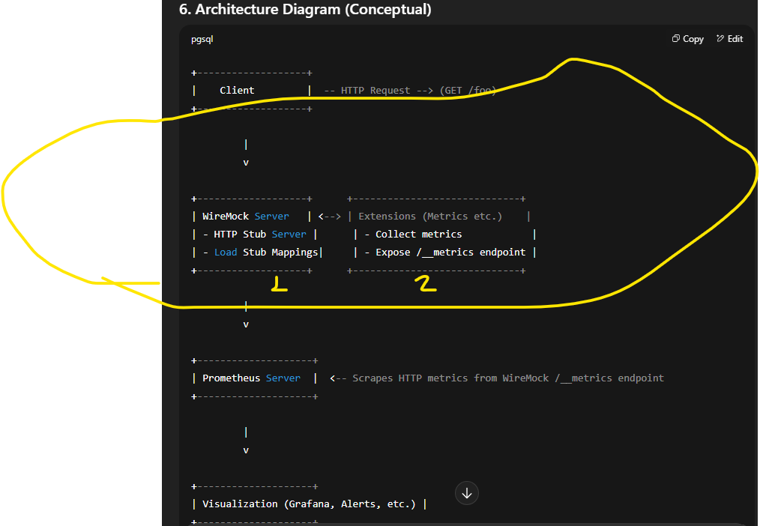

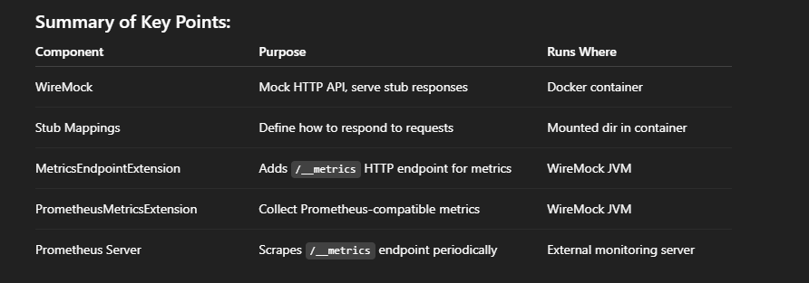

http://localhost:8080/__admin/mappings
http://localhost:8080/__metrics
http://localhost:8080/__admin/

Create at least one stub mapping to simulate real traffic:
Example mappings/example.json:
json
CopyEdit
{
"request": {
"method": "GET",
"url": "/hello"
},
"response": {
"status": 200,
"body": "Hello World"
}
}
Place it inside the mappings/ directory on the container (mount it from host).

docker run --rm -it -p 8080:8080 \
-v /var/wiremock/extensions/wiremock-metrics-1.0.4-standalone.jar:/var/wiremock/lib/wiremock-metrics-1.0.4-standalone.jar \
wiremock/wiremock:latest \
--extensions com.rasklaad.wiremock.metrics.MetricsEndpointExtension,com.rasklaad.wiremock.metrics.PrometheusMetricsExtension

https://github.com/rasklaad/wiremock-metrics?tab=readme-ov-file
https://wiremock.org/docs/download-and-installation/
https://github.com/rasklaad/wiremock-metrics/releases/

Single-Line Commands:-
These are written on one line and executed all at once. Example:
docker run -it --rm -p 8080:8080 --name wiremock wiremock/wiremock:3.13.1
This works fine and is ideal for short or simple commands.

✅ Multi-Line Commands:-
You use a backslash (\) at the end of each line except the last to break the command across multiple lines for readability.

The backslash must be the very last character — no trailing space after it.
[10:56, 13/08/2025] G: docker run -it --rm \
-p 8080:8080 \
--name wiremock \
wiremock/wiremock:3.13.1

WireMock with Prometheus Metrics Extension:-

is because the /__metrics endpoint is provided by your extension, but that extension only works if:
- The extension JAR is actually loaded into WireMock when you start it.
- At least one HTTP request has been handled so there’s something to report.
- (Optional but common) You have at least one stub mapping so you can generate predictable traffic.

So Start WireMock with the extension loaded:-
docker run --rm -it \
-p 8080:8080 \
-v /var/wiremock/extensions/wiremock-metrics-1.0.4-standalone.jar:/var/wiremock/lib/wiremock-metrics-1.0.4-standalone.jar \
wiremock/wiremock:latest \
--extensions com.rasklaad.wiremock.metrics.MetricsEndpointExtension,com.rasklaad.wiremock.metrics.PrometheusMetricsExtension

docker run --rm -it \
-p 8080:8080 \
-v /var/wiremock/mappings:/home/wiremock/mappings \
-v /var/wiremock/extensions/wiremock-metrics-1.0.4-standalone.jar:/var/wiremock/lib/wiremock-metrics-1.0.4-standalone.jar \
wiremock/wiremock:latest \
--extensions com.rasklaad.wiremock.metrics.MetricsEndpointExtension,com.rasklaad.wiremock.metrics.PrometheusMetricsExtension

WireMock is running fine and serving /hello, but /__metrics is being treated like any other request — and since no stub matches it, WireMock gives the default “not matched” message.
This happens when:
- The Prometheus metrics extension JAR is not mounted in the correct container path, or
- The --extensions parameter isn’t pointing to the right class names, or
- The Docker image is overwriting your mounted file due to wrong volume paths.

1st java -jar cfr.jar PrometheusMetricsExtension.class gebru.java / jar xf wiremock-metrics-1.0.4-standalone.jar
2st wget https://www.benf.org/other/cfr/cfr-0.152.jar -O cfr.jar
3nd decompile file :- java -jar cfr.jar MetricsEndpointExtension.class > MetricsEndpointExtension.java
Then open with vim the java file.

http://localhost:8080/__admin/prometheus-metrics
